**Project 2   
Deploy a Static Website on AWS**

**STEP 1: Sign in to AWS Management Console**

Click on the **Open Console**button, and you will get redirected to AWS Console in a new browser tab.

**STEP 2: Creating a S3 Bucket**

In this task, we are going to create a new S3 bucket in the US East (N. Virginia) region with a unique name disabling ACLs, and allowing public access for hosting the static website.

1. Navigate to **S3** by clicking on the **Services** menu at the top, then click on **S3** in the **Storage** section.
2. In the S3 dashboard, click on the**Create Bucket**button.
3. In the General Configuration, **Bucket name**:Enter **STATICWEB**
   * **Note:** S3 Bucket names are globally unique, choose an available name. Maybe you can enter your name and create one.
4. AWS Region:Select **US East (N. Virginia) us-east-1**
5. Object ownership: Select the **ACLs disabled (recommended)** option
6. In the option of **Block Public Access settings for this bucket**, **Uncheck** the option of **Block all public access**.
   * **Check** the I acknowledge that the current settings might result in this bucket and the objects within becoming public checkboxes.
7. Keep everything default and click on the **Create Bucket**button.

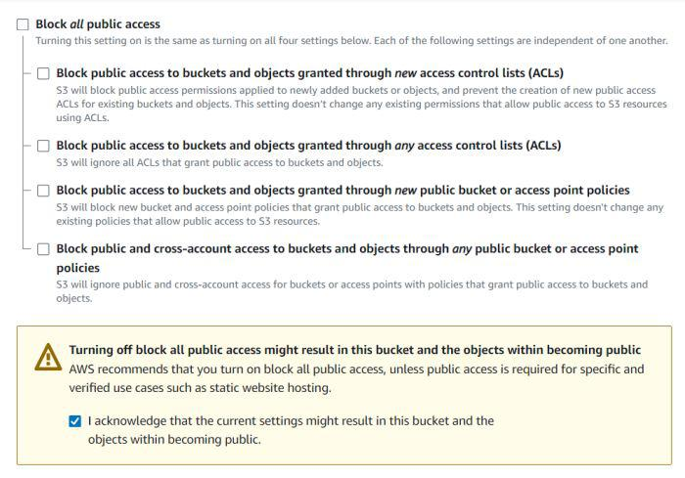

## STEP 3: Enable Static Website Hosting settings

In this task, we will enable static website hosting for our S3 bucket, configure it to use index.html and error.html, copy the provided endpoint, upload two files, and configure the bucket policy by copying its ARN and pasting the provided policy code.

1. To proceed, go to the **S3 bucket name** that you created and click on it. After that, navigate to the **Properties** tab which can be found at the top of the screen.
2. 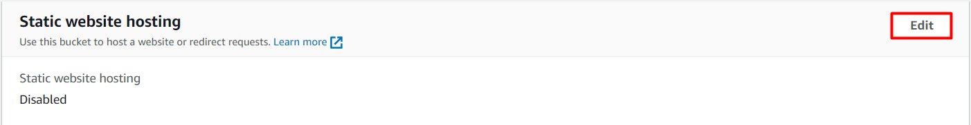Scroll down to the **Static website hosting** section and click on the **Edit** button.
3. In the **Static website hosting** dialog box

* Static website hosting: Select **Enable**
* Hosting type: Choose **Host a static website**
* Index document: Type ***index.html***
* Error document: Type ***error.html***
* Click on **Save Changes**.

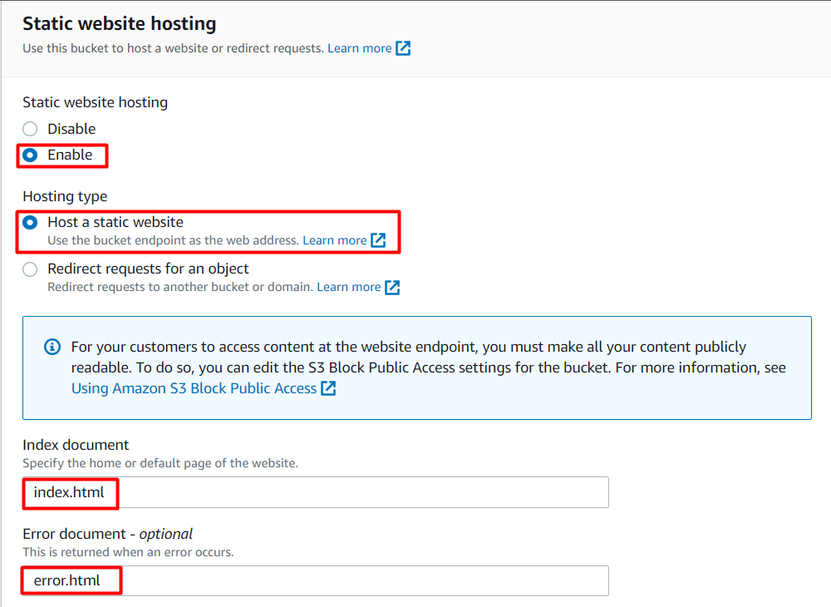

       4. Go to the **Properties** tab of your S3 bucket, and find the **Static website hosting** section. **Copy** the Endpoint provided in this section to your clipboard and **save** it for future reference.

      5. The next step is to download the zip file by clicking on the [link](https://labresources.whizlabs.com/2e8a0c891334fbb141d713fc9de61e60/task_23.zip), extract it, and upload two files named **index.html** and **error.html** to the S3 bucket you created earlier.

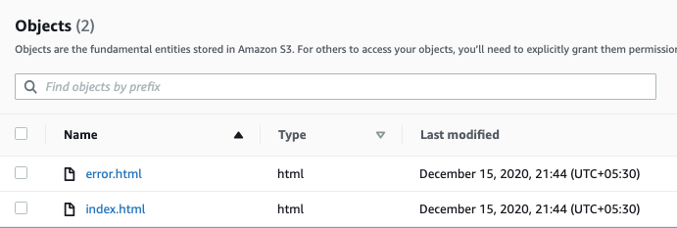

      6. To configure your S3 bucket, access the **Permissions** tab and make the necessary configurations.

* In the **Permissions** tab, Click on the **Edit** button beside the **Bucket Policy**.

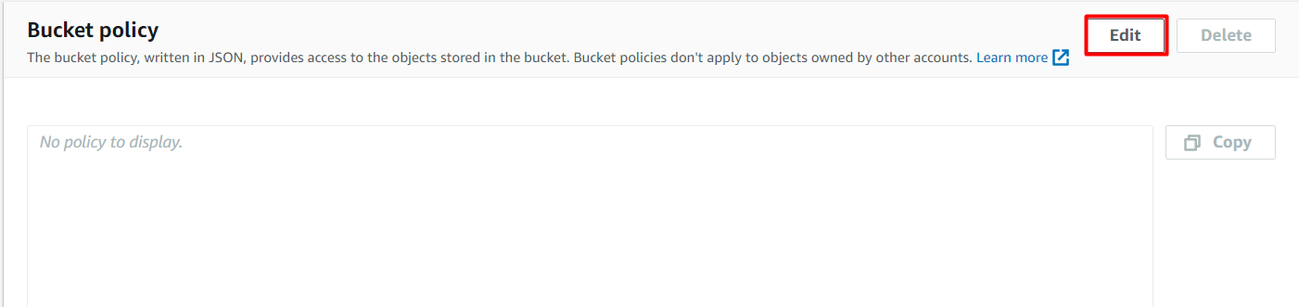

* You will be able to see a Blank policy editor.
* Before creating the policy, you will need to copy the **ARN** (Amazon Resource Name) of your bucket.
* Copy the **ARN** of your bucket to the clipboard. It is displayed at the top of the policy editor. it will look like **ARN: “arn:aws:s3:::your-bucket-name**".
* In the policy below, **Update** the bucket ARN on the Resource key value and **paste** the below policy code in the editor.

{

    "Id":"Policy1",

    "Version":"2012-10-17",

    "Statement":[

       {

          "Sid":"Stmt1",

          "Action":[

             "s3:GetObject"

          ],

          "Effect":"Allow",

          "Resource":"replace-this-string-with-your-bucket-arn/*",

          "Principal":"*"

       }

    ]

}

Click on the **Save Changes** button.

## STEP 4: Test the website

1. Now copy the **static website URL** (that we saved earlier) and run it in your browser. You will be able to see the index.html file's text. A sample screenshot is attached below:

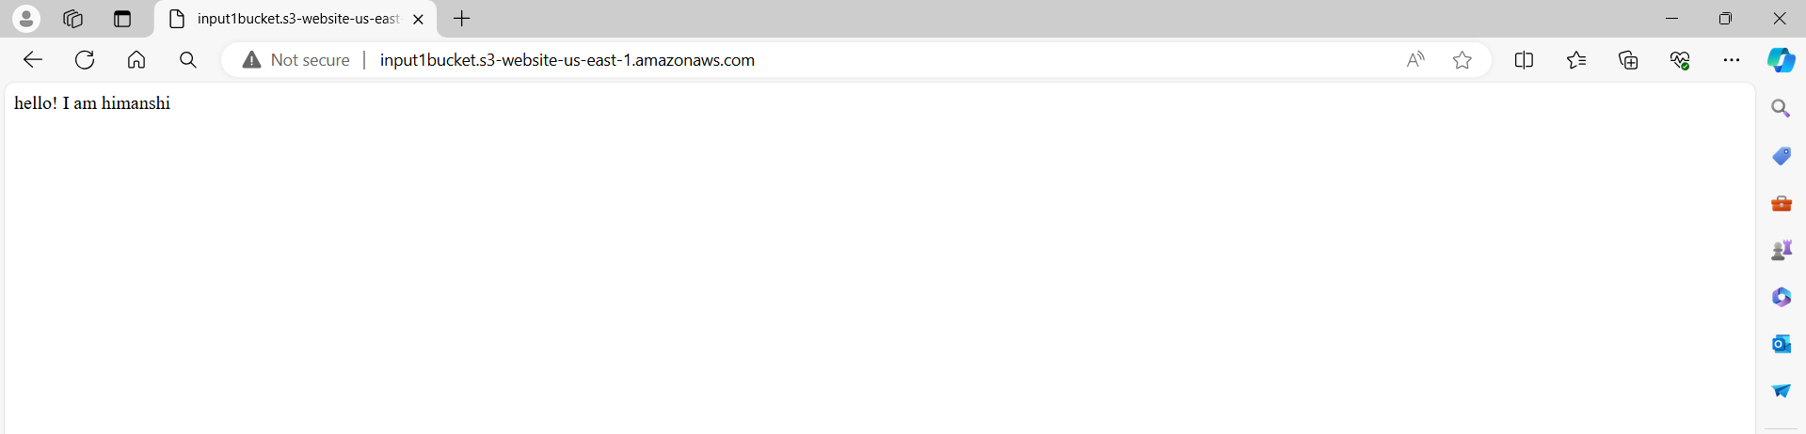

## STEP 5: Test the website's error page

Copy the static website URL (which we saved earlier), but this time, add some random characters to the end of the URL to break it. When satisfied, hit **[Enter]**. You will be redirected to the **error.html** page.

